**Student Elections User Manual**

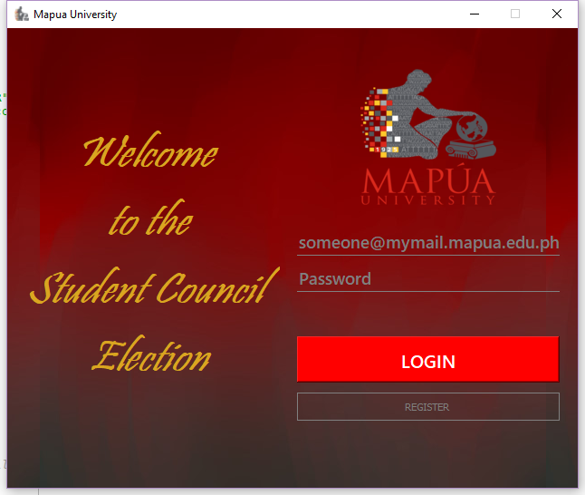

1. You will be introduced to the login window of the student election application. Enter your given email and password to proceed. If not, you may click the register button and you will be redirected to a new window.